Linear Pair Theorem
# Source: AI Source: Provided by: [Data Path: Persons Table -> ID Column: 1, Name_En Column: Motasem Essam] -> From: [ChatGPT] on [7/25/2026]
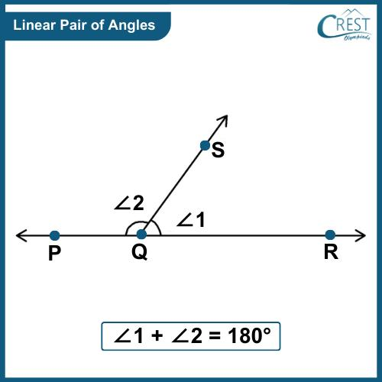
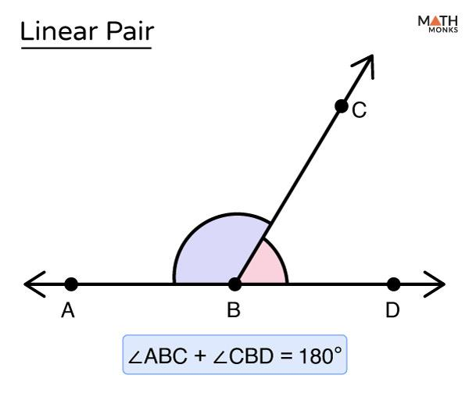
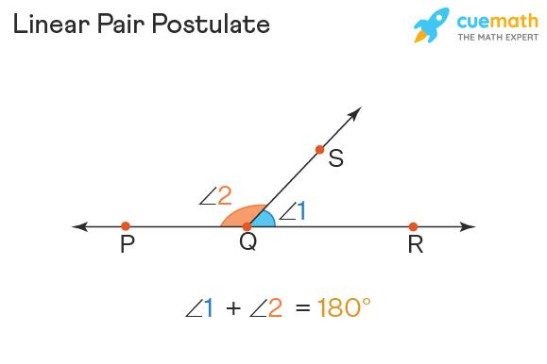

Definition
# Source: AI Source: Provided by: [Data Path: Persons Table -> ID Column: 1, Name_En Column: Motasem Essam] -> From: [ChatGPT] on [7/25/2026]
The Linear Pair Theorem, commonly called the Linear Pair Postulate, states that:
If two adjacent angles form a straight line, then they are supplementary.
Therefore, their measures add up to:
$$\boxed{{180}^{∘}}$$
For example, if $∠ABC$ and $∠CBD$ form a linear pair:
$$\boxed{m∠ABC+m∠CBD={180}^{∘}}$$

Purpose
# Source: AI Source: Provided by: [Data Path: Persons Table -> ID Column: 1, Name_En Column: Motasem Essam] -> From: [ChatGPT] on [7/25/2026]
The Linear Pair Theorem is used to:
- Find an unknown angle.
- Determine supplementary angles.
- Solve algebraic angle equations.
- Analyze intersecting lines.
- Prove that two angles are supplementary.
- Find relationships between adjacent angles.

Basic Configuration
# Source: AI Source: Provided by: [Data Path: Persons Table -> ID Column: 1, Name_En Column: Motasem Essam] -> From: [ChatGPT] on [7/25/2026]
Suppose $A$, $B$, and $D$ lie on the same straight line, and ray $\vec{BC}$ extends from $B$:
$$A←B→D$$
with ray $BC$ forming two adjacent angles.
The two angles are:
$$∠ABC$$
and:
$$∠CBD$$
Because $BA$ and $BD$ are opposite rays, they form a straight angle.
Therefore:
$\boxed{m∠ABC+m∠CBD={180}^{∘}}$
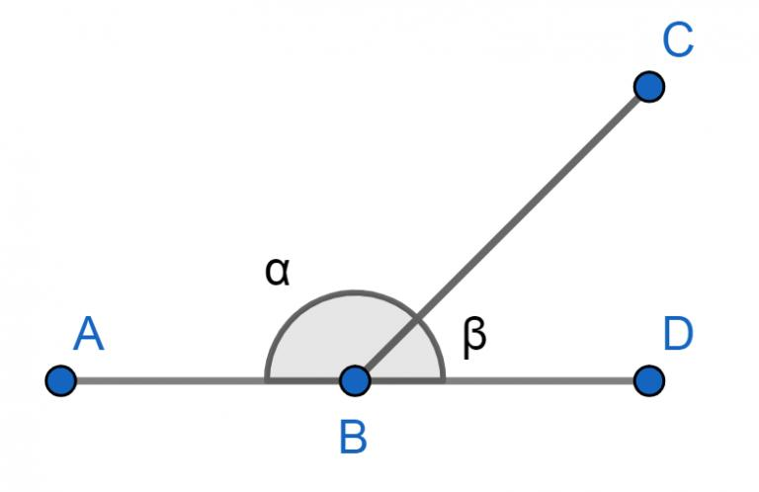

Mathematical Representation
# Source: AI Source: Provided by: [Data Path: Persons Table -> ID Column: 1, Name_En Column: Motasem Essam] -> From: [ChatGPT] on [7/25/2026]
The fundamental formula is:
$$\boxed{m∠1+m∠2={180}^{∘}}$$
Therefore:
$$\boxed{\text{Linear Pair}=\text{Two Adjacent Supplementary Angles}}$$
If one angle is known, the other can be found using:
$$\boxed{m∠2={180}^{∘}-m∠1}$$

Example 1 — Finding a Missing Angle
# Source: AI Source: Provided by: [Data Path: Persons Table -> ID Column: 1, Name_En Column: Motasem Essam] -> From: [ChatGPT] on [7/25/2026]
Suppose:
$$m∠1={65}^{∘}$$
and $∠1$ and $∠2$ form a linear pair.
Then:
$$m∠1+m∠2={180}^{∘}$$
Substitute:
$${65}^{∘}+m∠2={180}^{∘}$$
Therefore:
$m∠2={115}^{∘}$ $\boxed{m∠2={115}^{∘}}$

Example 2 — Algebraic Angles
# Source: AI Source: Provided by: [Data Path: Persons Table -> ID Column: 1, Name_En Column: Motasem Essam] -> From: [ChatGPT] on [7/25/2026]
Suppose two angles form a linear pair:
$m∠1=3x+10$ $m∠2=5x-20$
Because they form a linear pair:
$$(3x+10)+(5x-20)=180$$
Simplify:
$8x-10=180$ $8x=190$ $x=\frac{190}{8}$ $\boxed{x=23.75}$
Now calculate the angles:
$m∠1=3(23.75)+10={81.25}^{∘}$ $m∠2=5(23.75)-20={98.75}^{∘}$
Check:
$${81.25}^{∘}+{98.75}^{∘}={180}^{∘}$$

Example 3 — A Right Angle
# Source: AI Source: Provided by: [Data Path: Persons Table -> ID Column: 1, Name_En Column: Motasem Essam] -> From: [ChatGPT] on [7/25/2026]
If one angle in a linear pair is:
$${90}^{∘}$$
then the other must be:
$${180}^{∘}-{90}^{∘}={90}^{∘}$$
Therefore:
$$\boxed{{90}^{∘}+{90}^{∘}={180}^{∘}}$$
So, if one angle in a linear pair is a right angle, both angles are right angles.

Why Does a Linear Pair Equal ${180}^{∘}$?
# Source: AI Source: Provided by: [Data Path: Persons Table -> ID Column: 1, Name_En Column: Motasem Essam] -> From: [ChatGPT] on [7/25/2026]
A straight angle measures:
$${180}^{∘}$$
When a ray divides that straight angle into two adjacent angles, the two parts must add to the whole:
$$m∠1+m∠2={180}^{∘}$$
This is an application of the Angle Addition Theorem.
Thus:
$$\boxed{\text{Angle Addition}+\text{Straight Angle}=\text{Linear Pair}}$$

Relationship with the Angle Addition Theorem
# Source: AI Source: Provided by: [Data Path: Persons Table -> ID Column: 1, Name_En Column: Motasem Essam] -> From: [ChatGPT] on [7/25/2026]
The Linear Pair Theorem is closely connected to the Angle Addition Theorem.
If:
$$∠1+∠2=∠ABC$$
and $∠ABC$ is a straight angle, then:
$$m∠ABC={180}^{∘}$$
Therefore:
$$\boxed{m∠1+m∠2={180}^{∘}}$$
So the Linear Pair relationship can be understood as:
$$\boxed{\text{Two adjacent parts of a straight angle add to }{180}^{∘}}$$

Relationship with Vertical Angles
# Source: AI Source: Provided by: [Data Path: Persons Table -> ID Column: 1, Name_En Column: Motasem Essam] -> From: [ChatGPT] on [7/25/2026]
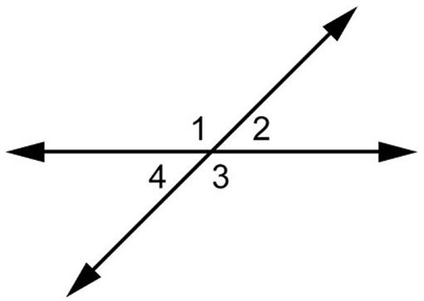
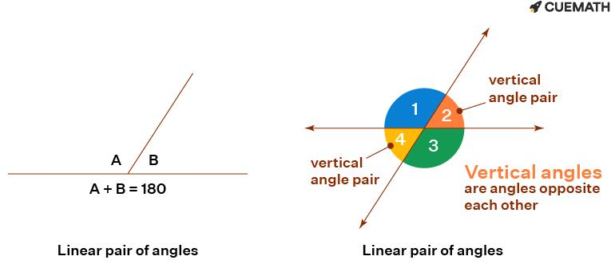
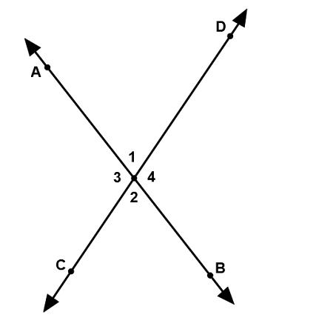
4
When two lines intersect, they create:
- Two pairs of vertical angles.
- Four adjacent angles.
- Two pairs of linear pairs.
For example:
$$∠1\text{ and }∠2$$
form a linear pair:
$$\boxed{m∠1+m∠2={180}^{∘}}$$
While:
$$∠1\text{ and }∠3$$
are vertical angles:
$$\boxed{m∠1=m∠3}$$
This means the two concepts work together.

Proof / Reasoning
# Source: AI Source: Provided by: [Data Path: Persons Table -> ID Column: 1, Name_En Column: Motasem Essam] -> From: [ChatGPT] on [7/25/2026]
Suppose $∠1$ and $∠2$ form a linear pair.
Because their non-common sides are opposite rays, together they form a straight angle.
A straight angle measures:
$${180}^{∘}$$
By the Angle Addition Theorem:
$$m∠1+m∠2={180}^{∘}$$
Therefore:
$$\boxed{∠1\text{ and }∠2\text{ are supplementary}}$$

Converse of the Linear Pair Theorem
# Source: AI Source: Provided by: [Data Path: Persons Table -> ID Column: 1, Name_En Column: Motasem Essam] -> From: [ChatGPT] on [7/25/2026]
An important distinction:

Linear Pair → Supplementary
# Source: AI Source: Provided by: [Data Path: Persons Table -> ID Column: 1, Name_En Column: Motasem Essam] -> From: [ChatGPT] on [7/25/2026]
If two angles form a linear pair, then:
$$\boxed{m∠1+m∠2={180}^{∘}}$$
However, two supplementary angles do not necessarily form a linear pair.
For example:
$${60}^{∘}+{120}^{∘}={180}^{∘}$$
These two angles are supplementary, but they only form a linear pair if they are adjacent and their non-common sides form a straight line.
So:
$$\boxed{\text{Linear pair}⇒\text{supplementary}}$$
but:
$$\boxed{\text{Supplementary}⇏\text{linear pair}}$$
in general.

Important Properties

1. The angles are adjacent
# Source: AI Source: Provided by: [Data Path: Persons Table -> ID Column: 1, Name_En Column: Motasem Essam] -> From: [ChatGPT] on [7/25/2026]
They share:
- The same vertex.
- One common side.
- No overlapping interior points.

2. Their non-common sides are opposite rays
# Source: AI Source: Provided by: [Data Path: Persons Table -> ID Column: 1, Name_En Column: Motasem Essam] -> From: [ChatGPT] on [7/25/2026]
This is what creates the straight line.

3. Their measures add to ${180}^{∘}$
# Source: AI Source: Provided by: [Data Path: Persons Table -> ID Column: 1, Name_En Column: Motasem Essam] -> From: [ChatGPT] on [7/25/2026]
$$\boxed{m∠1+m∠2={180}^{∘}}$$

4. They are supplementary
# Source: AI Source: Provided by: [Data Path: Persons Table -> ID Column: 1, Name_En Column: Motasem Essam] -> From: [ChatGPT] on [7/25/2026]
Every linear pair consists of supplementary angles.

5. They do not have to be equal
# Source: AI Source: Provided by: [Data Path: Persons Table -> ID Column: 1, Name_En Column: Motasem Essam] -> From: [ChatGPT] on [7/25/2026]
For example:
$${70}^{∘}+{110}^{∘}={180}^{∘}$$
The angles form a linear pair even though:
$${70}^{∘}≠{110}^{∘}$$

Special Cases

Equal Linear-Pair Angles
# Source: AI Source: Provided by: [Data Path: Persons Table -> ID Column: 1, Name_En Column: Motasem Essam] -> From: [ChatGPT] on [7/25/2026]
If the two angles are equal:
$$m∠1=m∠2$$
and:
$$m∠1+m∠2={180}^{∘}$$
then:
$$2m∠1={180}^{∘}$$
so:
$$\boxed{m∠1=m∠2={90}^{∘}}$$
Thus, two equal angles forming a linear pair must both be right angles.

Linear Pair vs. Vertical Angles
# Source: AI Source: Provided by: [Data Path: Persons Table -> ID Column: 1, Name_En Column: Motasem Essam] -> From: [ChatGPT] on [7/25/2026]
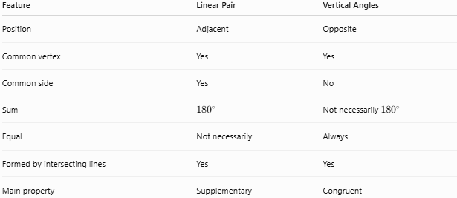
Feature | Linear Pair | Vertical Angles
Position | Adjacent | Opposite
Common vertex | Yes | Yes
Common side | Yes | No
Sum | $${180}^{∘}$$ | Not necessarily ${180}^{∘}$
Equal | Not necessarily | Always
Formed by intersecting lines | Yes | Yes
Main property | Supplementary | Congruent
For example, if one angle is ${70}^{∘}$:
Linear-pair angle:
$${180}^{∘}-{70}^{∘}={110}^{∘}$$
Vertical angle:
$${70}^{∘}$$

Comparison with Related Concepts
# Source: AI Source: Provided by: [Data Path: Persons Table -> ID Column: 1, Name_En Column: Motasem Essam] -> From: [ChatGPT] on [7/25/2026]
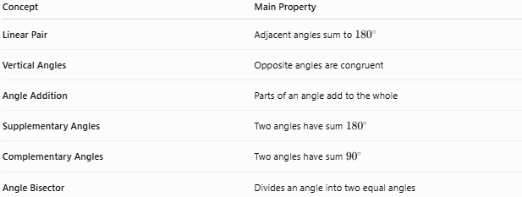
Concept | Main Property
Linear Pair | Adjacent angles sum to ${180}^{∘}$
Vertical Angles | Opposite angles are congruent
Angle Addition | Parts of an angle add to the whole
Supplementary Angles | Two angles have sum ${180}^{∘}$
Complementary Angles | Two angles have sum ${90}^{∘}$
Angle Bisector | Divides an angle into two equal angles

Applications
# Source: AI Source: Provided by: [Data Path: Persons Table -> ID Column: 1, Name_En Column: Motasem Essam] -> From: [ChatGPT] on [7/25/2026]
The Linear Pair Theorem is used in:
- Plane geometry.
- Intersecting-line problems.
- Triangle problems.
- Parallel-line and transversal problems.
- Algebraic angle problems.
- Geometric proofs.
- Engineering drawings.
- Architectural diagrams.
- Technical drafting.

Common Mistakes

Mistake 1 — Assuming any two supplementary angles form a linear pair
# Source: AI Source: Provided by: [Data Path: Persons Table -> ID Column: 1, Name_En Column: Motasem Essam] -> From: [ChatGPT] on [7/25/2026]
Not necessarily.
They must also be adjacent and have opposite rays as their non-common sides.

Mistake 2 — Assuming a linear pair has equal angles
# Source: AI Source: Provided by: [Data Path: Persons Table -> ID Column: 1, Name_En Column: Motasem Essam] -> From: [ChatGPT] on [7/25/2026]
A linear pair only guarantees:
$$m∠1+m∠2={180}^{∘}$$
It does not guarantee:
$$m∠1=m∠2$$

Mistake 3 — Confusing linear pairs with vertical angles
# Source: AI Source: Provided by: [Data Path: Persons Table -> ID Column: 1, Name_En Column: Motasem Essam] -> From: [ChatGPT] on [7/25/2026]
- Linear pair: next to each other.
- Vertical angles: opposite each other.

Key Points
# Source: AI Source: Provided by: [Data Path: Persons Table -> ID Column: 1, Name_En Column: Motasem Essam] -> From: [ChatGPT] on [7/25/2026]
- A linear pair consists of two adjacent angles.
- Their non-common sides are opposite rays.
- They form a straight angle.
- Their measures always add to:
$$\boxed{{180}^{∘}}$$
- Therefore, every linear pair is supplementary.
- Linear-pair angles are not necessarily equal.
- If the two linear-pair angles are equal, each must be:
$$\boxed{{90}^{∘}}$$
- Linear pairs and vertical angles commonly appear together when two lines intersect.

Conclusion
# Source: AI Source: Provided by: [Data Path: Persons Table -> ID Column: 1, Name_En Column: Motasem Essam] -> From: [ChatGPT] on [7/25/2026]
The Linear Pair Theorem states that two adjacent angles whose non-common sides form a straight line are supplementary:
$$\boxed{m∠1+m∠2={180}^{∘}}$$
The essential idea is:
$$\boxed{\text{Linear Pair}=\text{Adjacent Angles}+\text{Straight Line}}$$
Therefore:
$$\boxed{\text{Linear Pair}⇒\text{Supplementary Angles}}$$
It is a fundamental theorem for solving angle problems and works especially well with the Angle Addition Theorem and Vertical Angle Theorem.

